Visualizing Housing Market Trends:An Analaysis Of Sale Prices And Features Using Tableau

**Submitted To: ABC Company**

**Submitted By: Rama Pravallika Nukala**

**Date: 2 July**

1. **INTRODUCTION**

**1.1 Project Overview**

**The project aims to analyze housing market trends using Tableau, leveraging data visualization to understand sale prices, house features, and the effect of renovations. It is developed for ABC Company to assist in making strategic business decisions.**

**1.2 Purpose**

**To identify and visualize patterns in house sales data and provide actionable insights to real estate stakeholders.**

**2.IDEATION PHASE**

**2.1 Problem StatementReal estate stakeholders face difficulty interpreting raw housing data. Understanding the effect of features like renovation, age, and house size on prices is critical.**

|  |  |  |  |  |  |
| --- | --- | --- | --- | --- | --- |
| **Problem**  **Statement**  **(PS)** | **I am**  **(Customer)** | **I’m trying to** | **But** | **Because** | **Which makes me**  **feel** |
| PS-1 | A first-time  homebuyer exploring housing options. | Understand what features  affect housing prices and identify affordable homes that meet my criteria. | The available data is scattered, difficult to interpret, and lacks visual clarity. | There is no unified platform or dashboard that simplifies housing data for easy comparison and decision making. | Confused,  overwhelmed, and uncertain about making a  high-stakes financial decision. |
| PS-2 | A real estate analyst working for an investment firm. | Identify housing market trends, outliers, and patterns in sale prices over time and across locations. | Traditional reports and spread sheets are time consuming to analyze and often miss insights hidden in large datasets. | There’s a lack of interactive tools that allow deep, dynamic exploration of the data. | Frustrated and inefficient in providing timely,  data-driven insights to stakeholders. |

**2.2 Empathy Map CanvasBuyers need to understand pricing logic. Sellers need to optimize their renovation investments. Analysts need visual tools to explore patterns.**

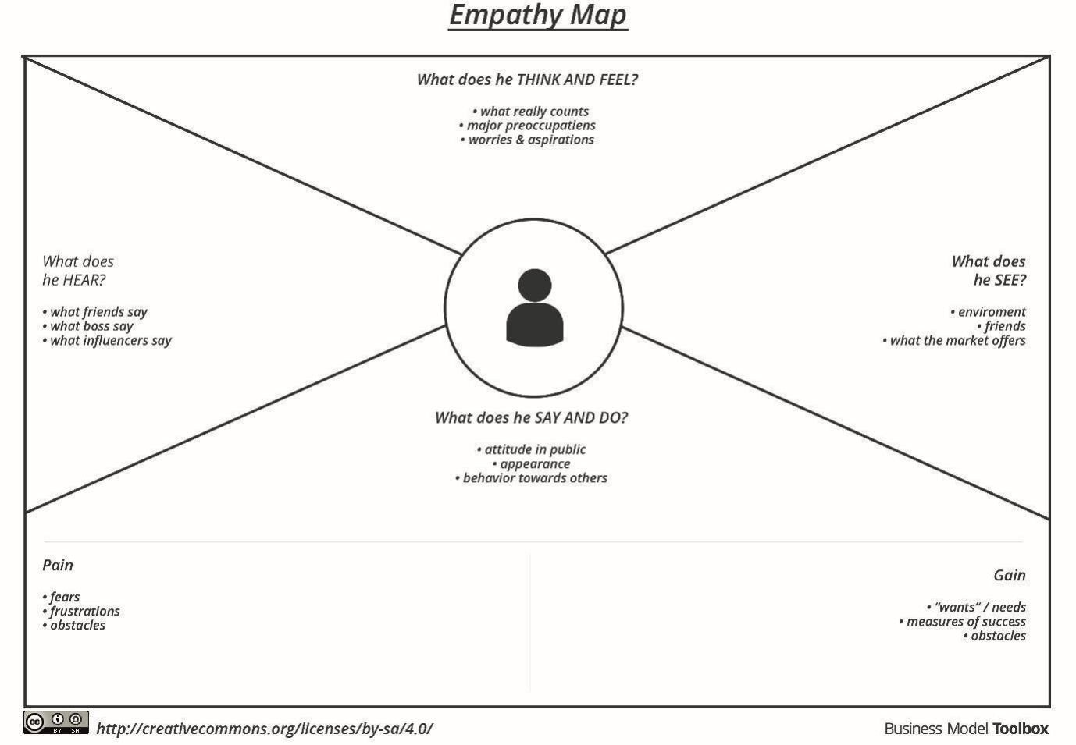**2.3 BrainstormingIdeas included: filtering sales by renovation year, mapping house age to features, analyzing distribution of features and sales prices.**

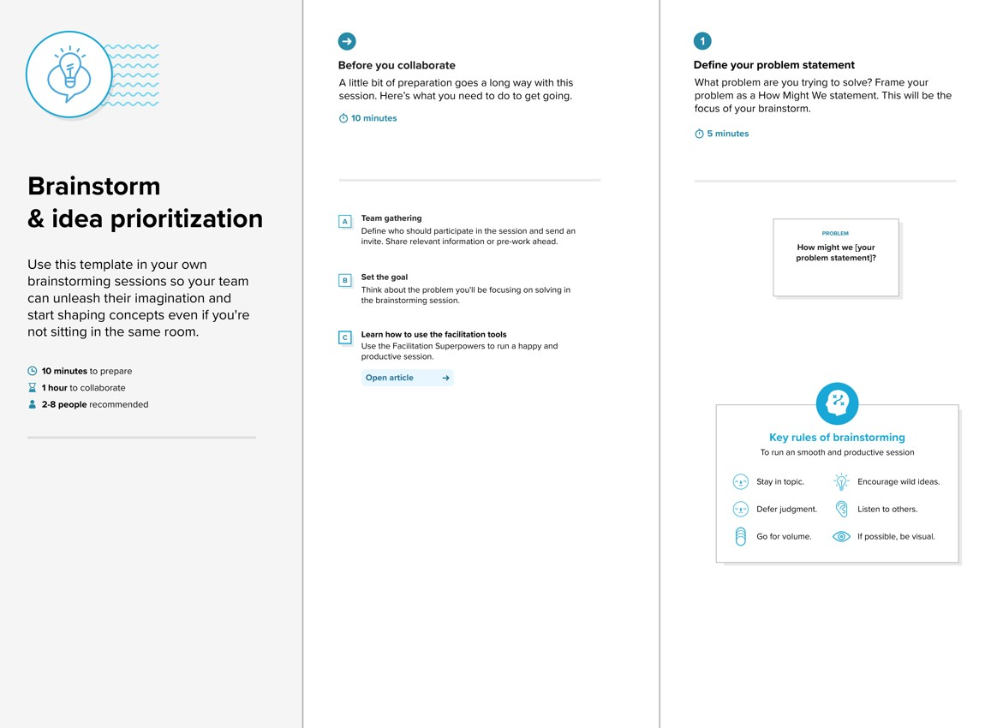

**3. REQUIREMENT ANALYSIS**

**3.1 Customer Journey MapIdentify how buyers move from browsing to purchase, influenced by renovation and house condition.3.2 Solution RequirementInteractive dashboards, filters, and stories in Tableau; insights on renovation impact, house size, and price trends.3.3 Data Flow DiagramRaw dataset → Preprocessing → Tableau visualizations → Dashboards/Stories.**

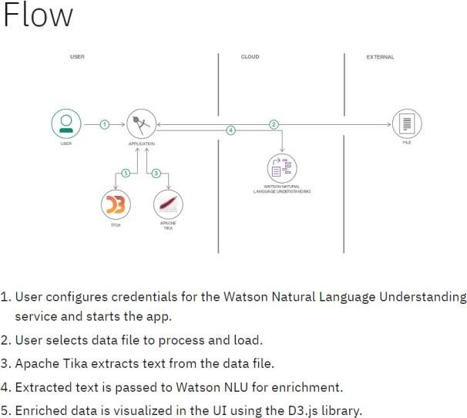**3.4 Technology StackTableau, Kaggle housing data set, optional pre processing in Excel.**

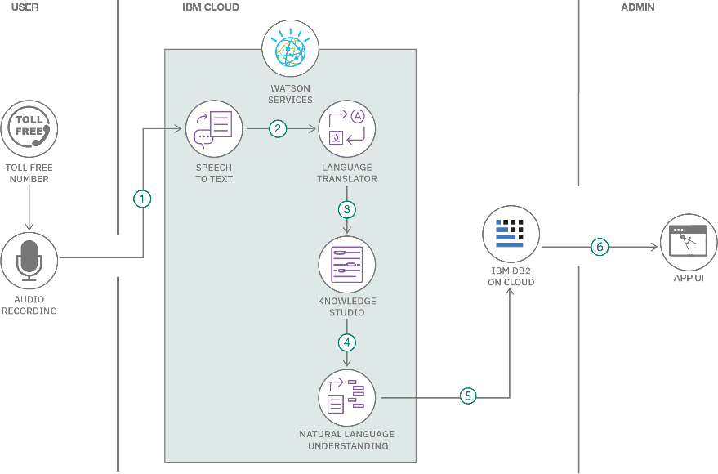

**4. PROJECT DESIGN**

**4.1 Problem Solution Fit**

**Tableau dashboards solve the problem of making complex data understandable for various stakeholders.**

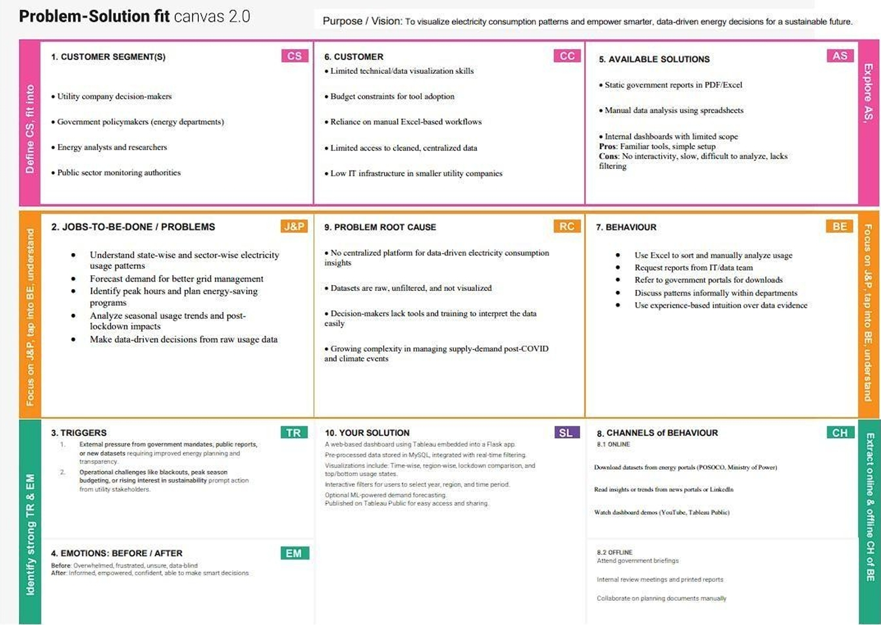**4.2 Proposed SolutionUse 4 visualizations to represent sales trends, renovation impact, and feature distributions.**

|  |  |
| --- | --- |
| S.No.Parameter | Description |
| 1.problem  statement | The real estate market involves vast and complex datasets on housing features and sale prices. These datasets are often underutilized due to lack of effective visualization, making it difficult for buyers, sellers, and analysts to draw insights or fore caste trends. |
| 2.Idea  /Solution Description | Our solution transforms static housing datasets into interactive, insightful visualizations using Tableau. The project involves cleaning and transforming the data, creating calculated fields and KPI s, and developing a dashboard that highlights key trends, comparisons, and location-based analyses. The solutions is deployed via flask web app. |
| 3.Novelty/Uniqueness | This project leverages Tableau’s powerful visual capabilities to go beyond basic data analytics. By combining calculated fields, condition segmentation, and geographic mapping,the dashboard offers a dynamic exploration of how features like bedrooms, area, renovation, and location influence housing prices. |
| 4. Social Impact /Customer Satisfaction | This solution enables real estate buyers, sellers, agents, and market researchers to make informed decisions. It improves housing transparency, supports better urban planning, and enhances user engagement with clear visuals and actionable insights. |
| 5. Business Model (Revenue of Model) | This dashboard can be scaled and offered as a subscription-based SaaS tool to real estate companies, market research firms, or housing consultancies. Advanced forecasting modules, API integrations, and custom dashboards can be monetized as premium features. |
| 6. Scalability the Solution | The system is designed to be scalable and adaptable. It can incorporate new datasets (like rental trends or economic indicators), extend to new regions or cities, and integrate with ML models for price predictions,there by offering long-term growth potential. |

**4.3 Solution ArchitectureData Source → Tableau Workbook → Dashboards → Storyline → Strategic Insights.**

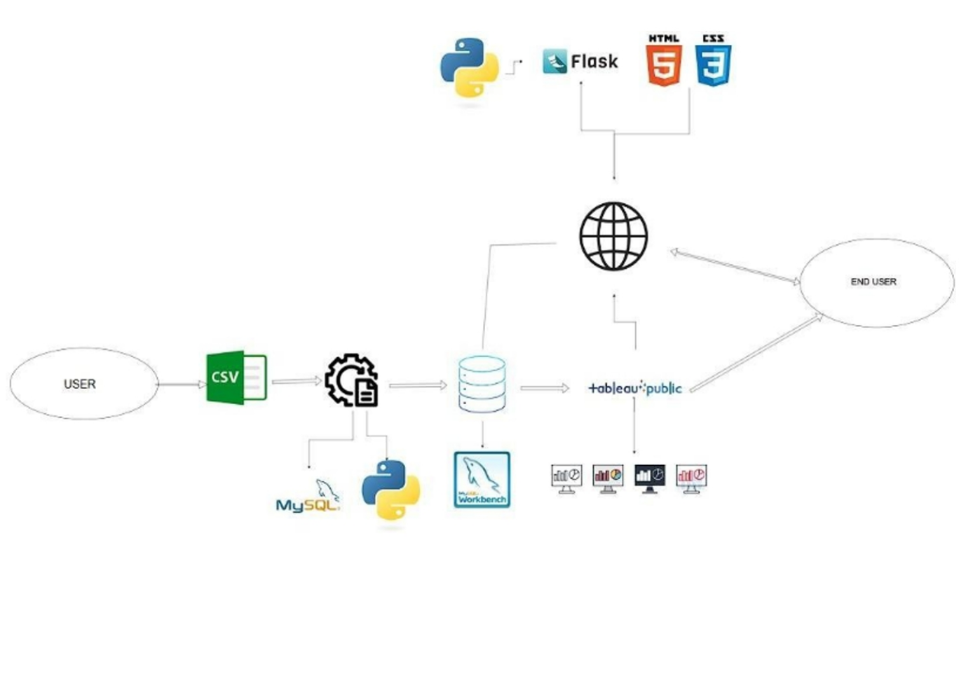

**5. PROJECT PLANNING & SCHEDULING**

**5.1 Project PlanningTasks were divided into data analysis, visualization, dashboard design, testing, and report writing. Each task had a 2-day interval using agile approach with story points assigned.**

| **Sprint** | **Functional Requirement (Epic)** | **User Story Number** | **User Story / Task** | **Story Points** | **Priority** |
| --- | --- | --- | --- | --- | --- |
| Sprint-1 | Data Setup | USN-1 | As a user, I can upload housing data in CSV format | 3 | High |
| Sprint-1 | Data Cleaning | USN-2 | As a developer, I can clean and preprocess housing data in Tableau | 4 | High |
| Sprint-1 | Field Creation | USN-3 | As a user, I can create calculated fields like TotalAreaSqft | 2 | Medium |
| Sprint-1 | Price BInning | USN-4 | As a user, I can create Sale Price Bin for grouping houses | 2 | Medium |
| Sprint-2 | Data Visualization | USN-5 | As a user, I can create sheets with charts: price vs feature | 5 | High |
| Sprint-2 | Dashboard Creation | USN-6 | As a user, I can build an interactive Tableau Dashboard with filters | 3 | High |

**6. FUNCTIONAL AND PERFORMANCE TESTING**

**6.1 Performance TestingPerformance tested via Tableau responsiveness and interactivity. 4 graphs in 1 dashboard and 1 story were evaluated. Filters, calculated fields, and user interactions were verified.**

**Model Performance Testing:**

|  |  |  |
| --- | --- | --- |
| **S.No.** | **Parameter** | **Screenshot / Values** |
|  | Data Rendered | Housing dataset containing features like Sale Price, Year Built, Renovation Year, Lot Area, Bedrooms, Bathrooms, etc. |
|  | Data Preprocessing | Missing values handled, Log transformation on skewed features (e.g., SalePrice), Feature scaling, Feature selection using correlation |
| 3. | Utilization of Filters | Filter by Renovation Status, Filter by Sale Price range, Filter by Number of Bedrooms, Year Built filter |
| 4. | Calculation fields Used | Total Sales by Year (e.g., SUM(SalePrice)), Price per SqFt (SalePrice / LotArea), Age of House (2025 - YearBuilt) | |
| 5. | Dashboard design | No of Visualizations / Graphs – 4(in each dashboard)  No of dashboard-1 |
| 6 | Story Design | No of Visualizations / Graphs – 4  No of stories-1 |

**7. RESULTS**

**7.1 Output Screenshots**

**Visualization 1**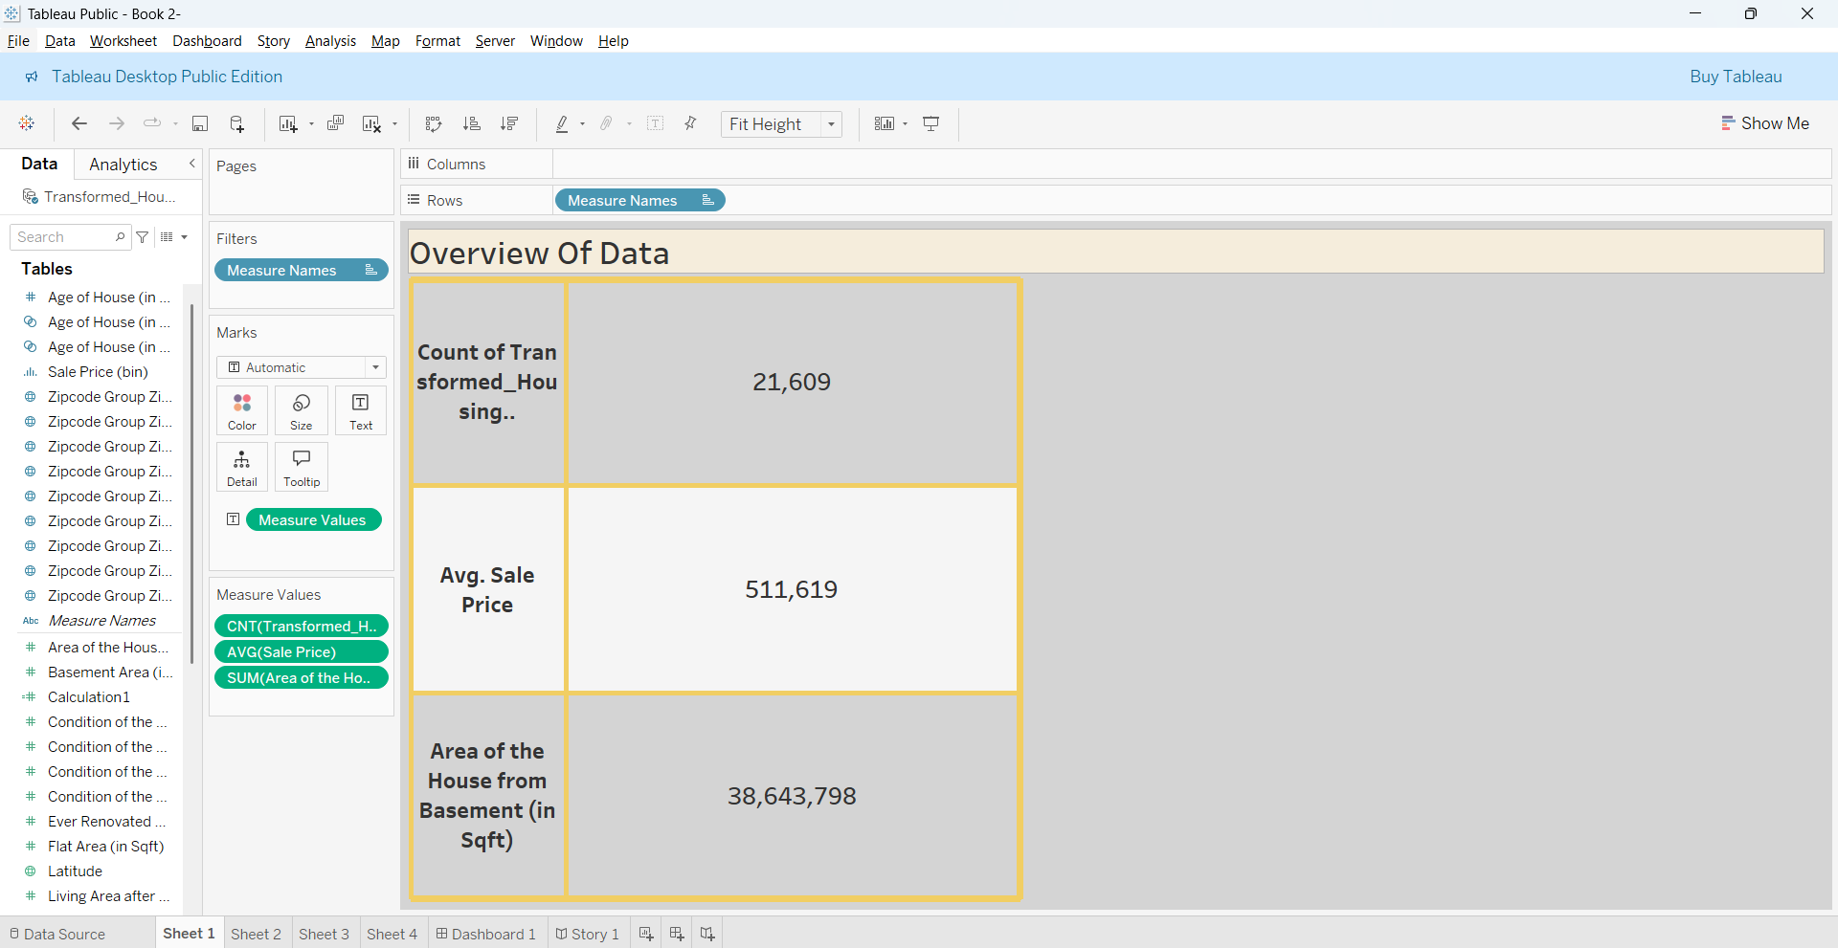

**Visualization 2:**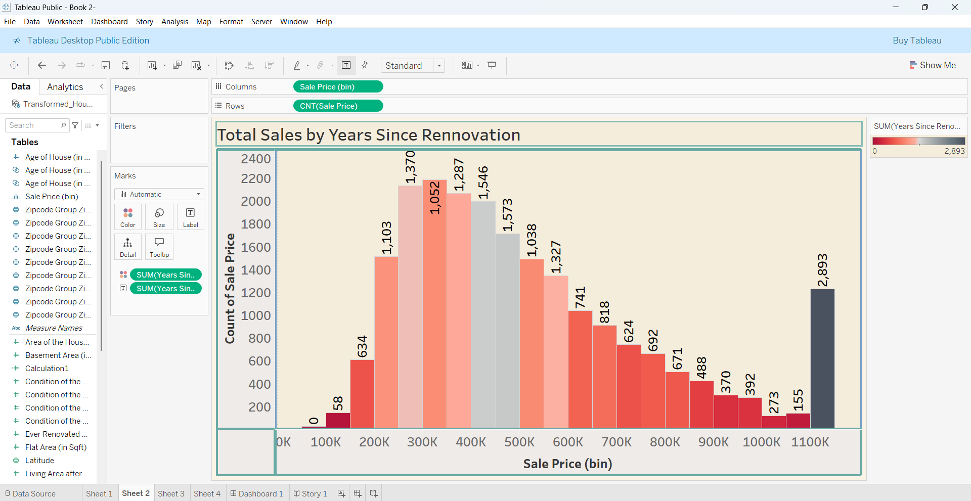

**Visualization 3:**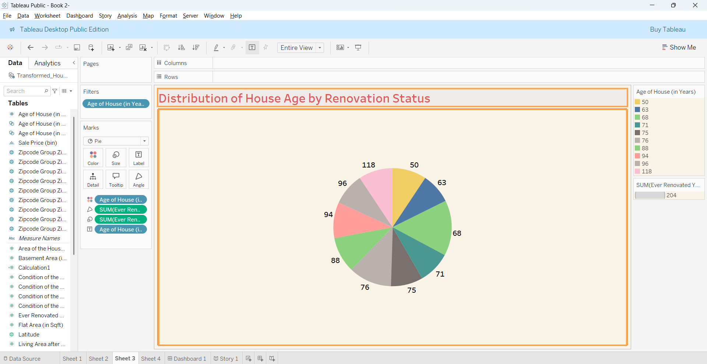

**Visualization 4:**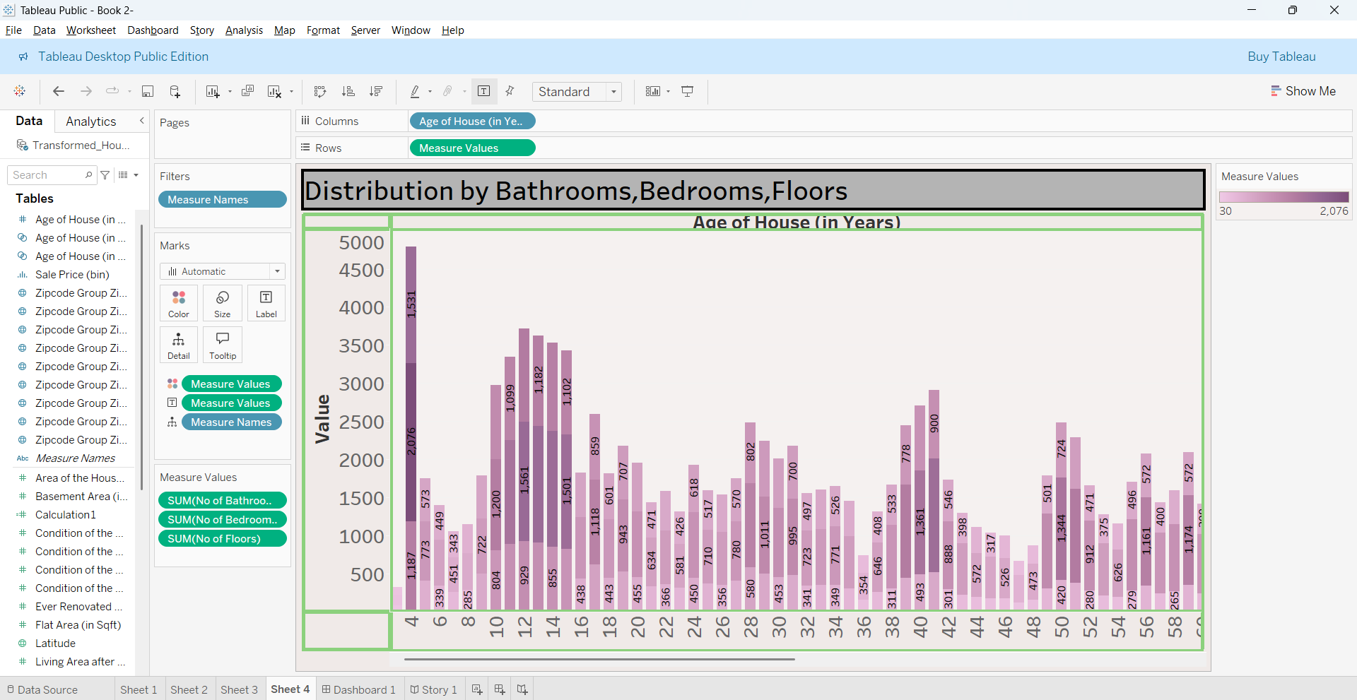

**DASHBOARD:**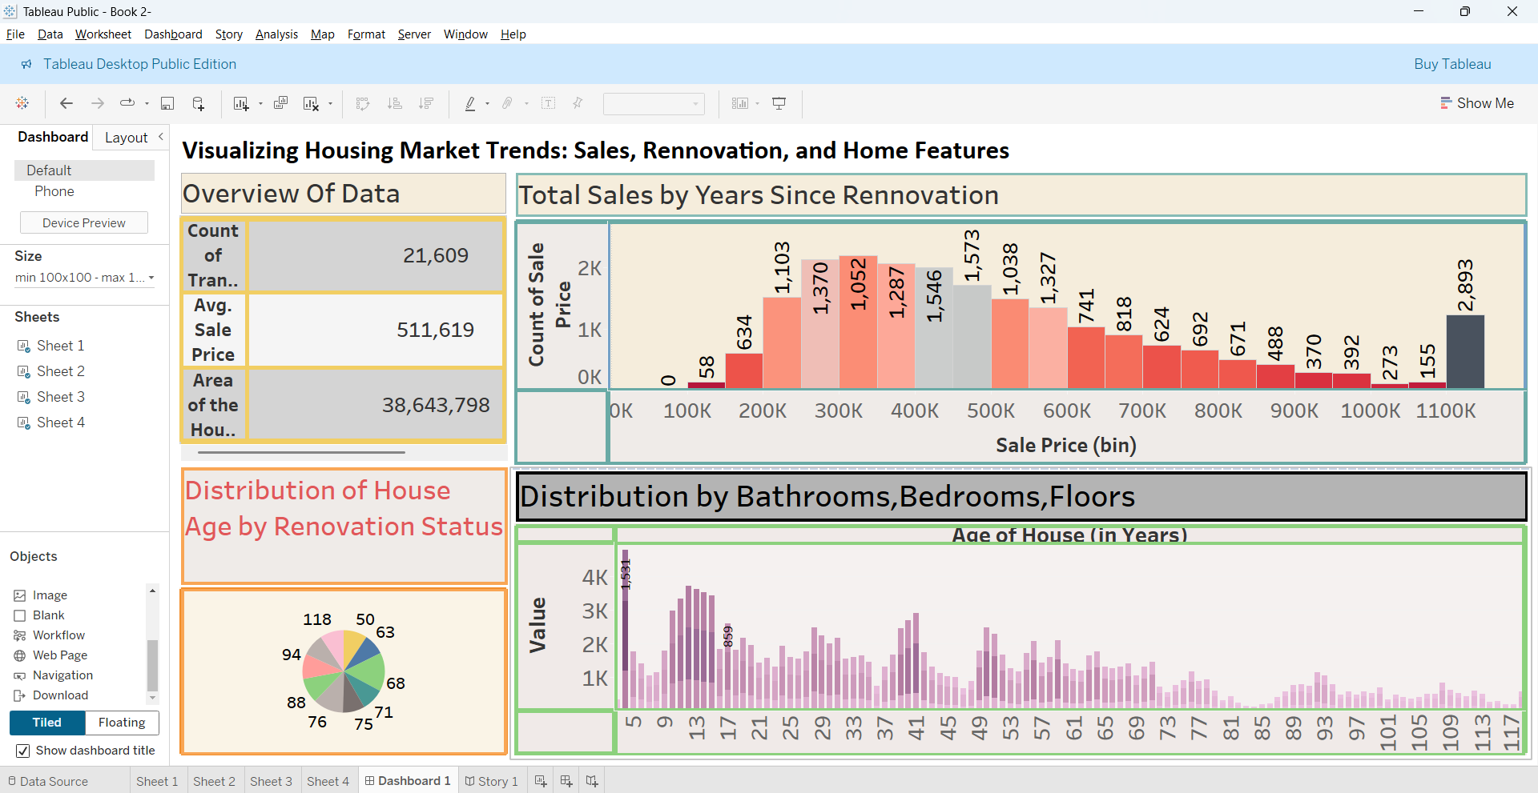

**8. ADVANTAGES & DISADVANTAGES**

**Advantages:  
- Easy-to-understand visuals  
- Real-time interactivity  
- Helps strategic planning**

**Disadvantages:  
- Limited by Tableau feature scope  
- Data needs preprocessing externally**

**9. CONCLUSION**

**The project successfully provided insights into housing market patterns. Stakeholders can now visualize how renovations, house features, and age affect pricing and sales performance.**

**10. FUTURE SCOPE**

**Integrate machine learning models for price prediction. Expand dataset across cities. Use real-time market data for trend forecasting.**

**11. APPENDIX**

**1. Dataset: <https://www.kaggle.com/datasets/rituparnaghosh18/transformed-housing-data-2>2.project Demo:**

**<https://drive.google.com/file/d/13JehMf9-NgoAvs9UqEMnFCN0Eu3wXDBk/view?usp=sharing>**